* **The Projects uses the following services from AWS:-**

**1.Elastic Cloud Compute (EC2)**

**2.Simple Storage Service (S3)**

**3.Rekognition**

* **User Service:**

**1. Telegram**

**SCREENSHOTS FOR THE PROCESSES INVOLVED:-**

* **AWS LOGIN SCREEN WITH USERNAME:-**

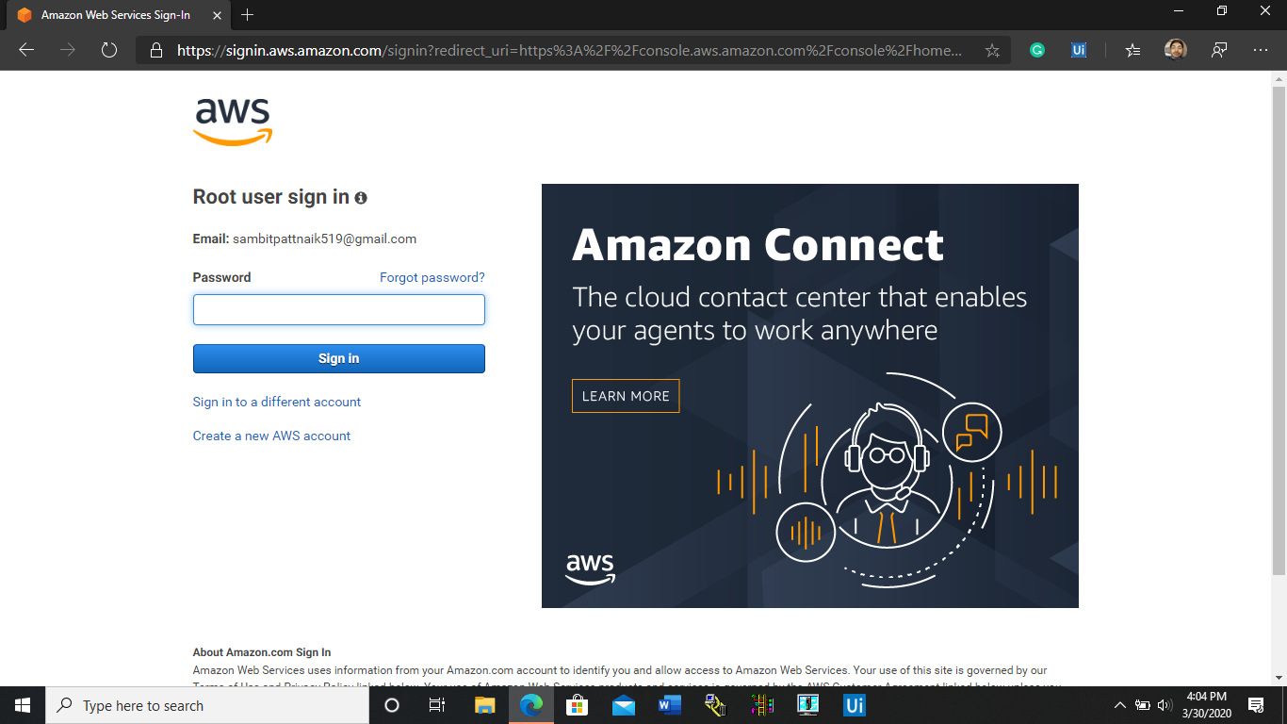

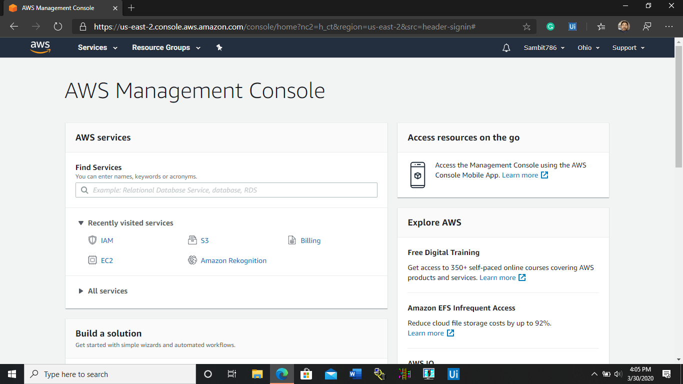

* **EC2 DASHBOARD:-**

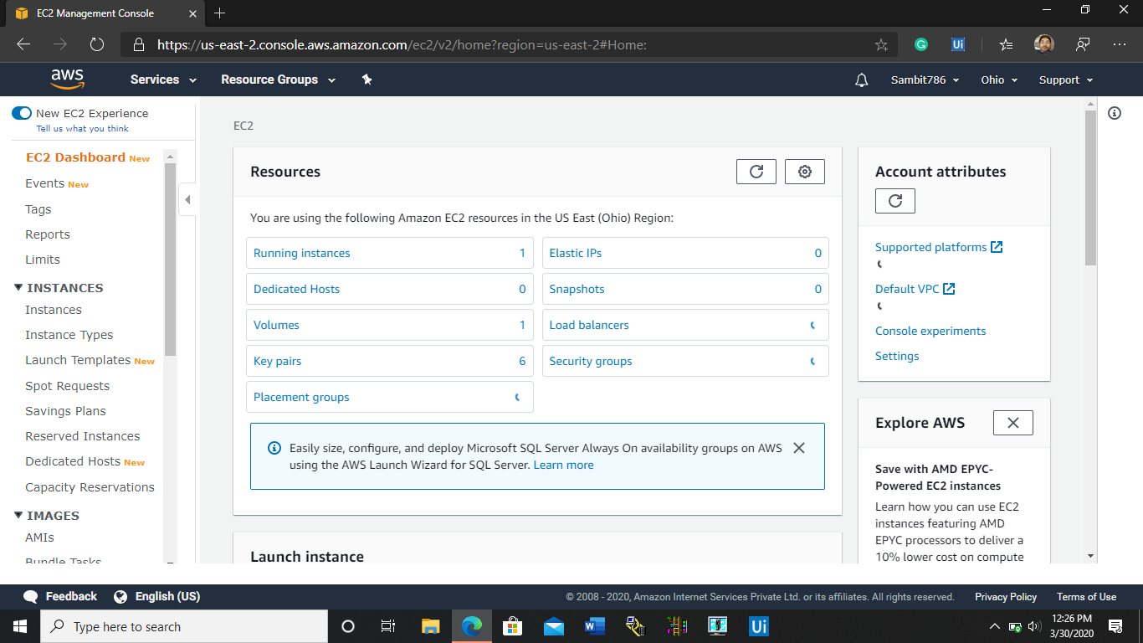

* **S3 DASHBOARD:-**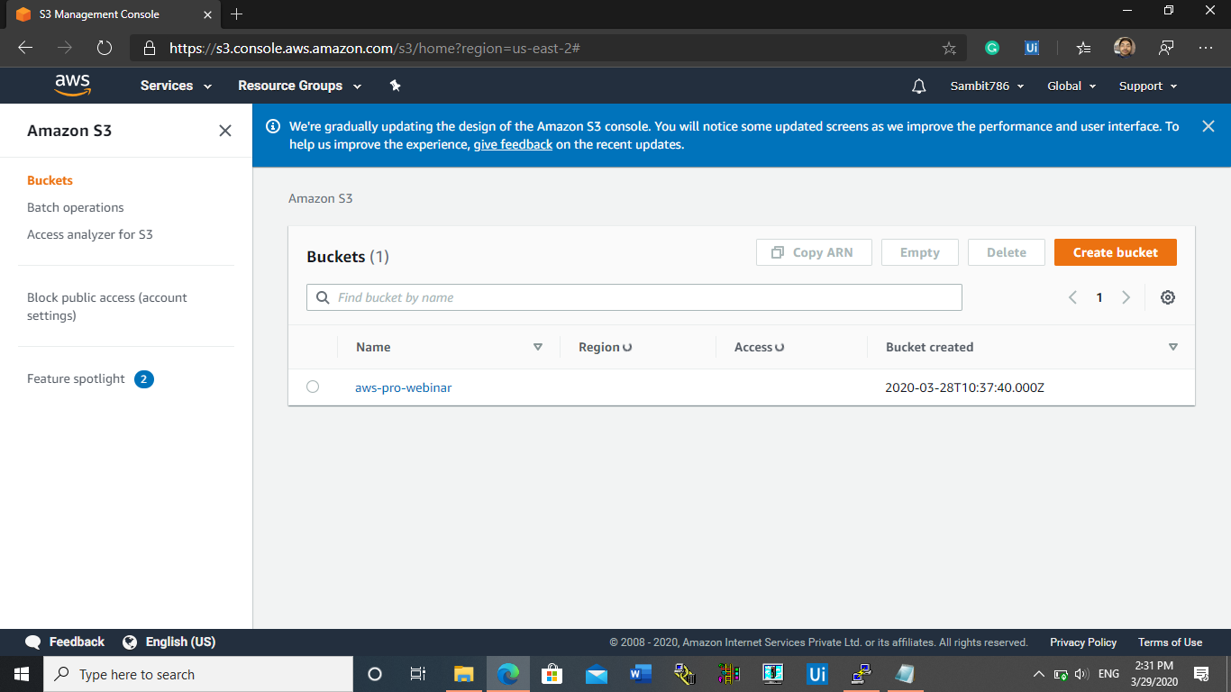
* **REKOGNITION DASHBOARD:-**

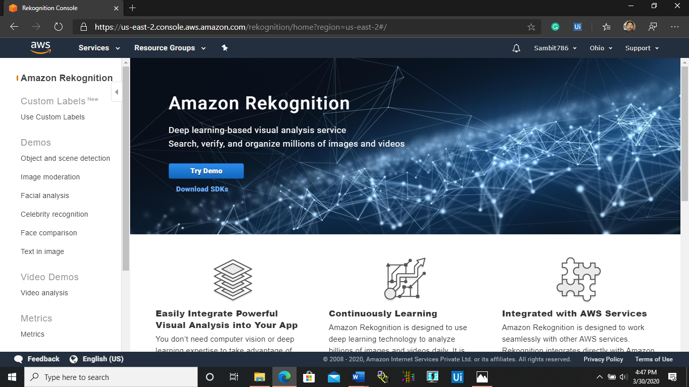

**STEPS INVOLVED IN CREATING INSTANCES AND CONNECTING TO APACHE SERVER USING EC2:-**

* **AMAZON MACHINE IMAGE (VIRTUAL O.S.):-**

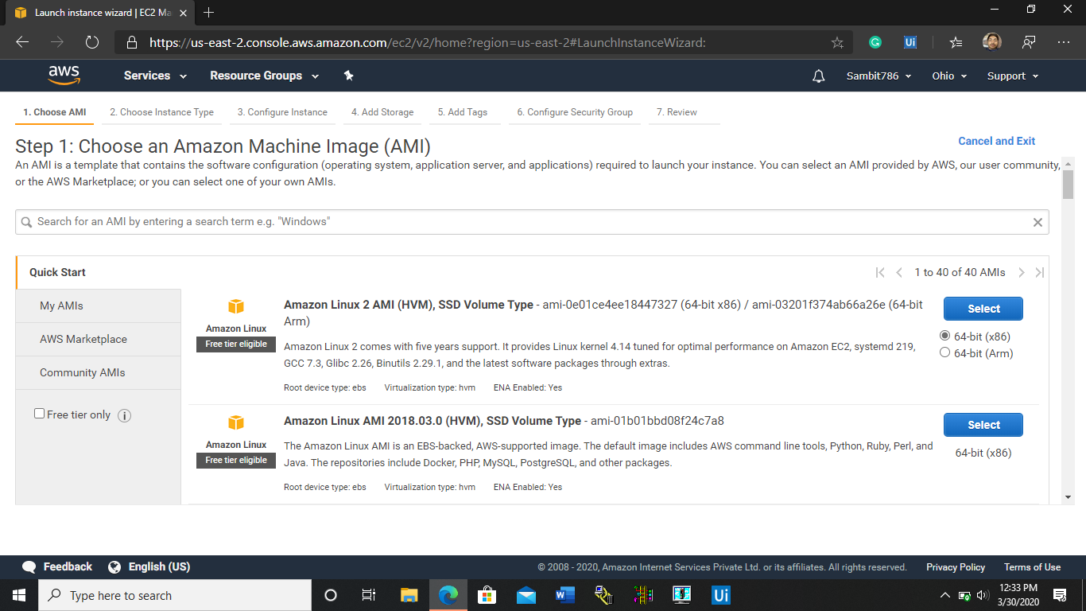

* **INSTANCE TYPE (USAGE OF no. of CPUs and Memory Space):-**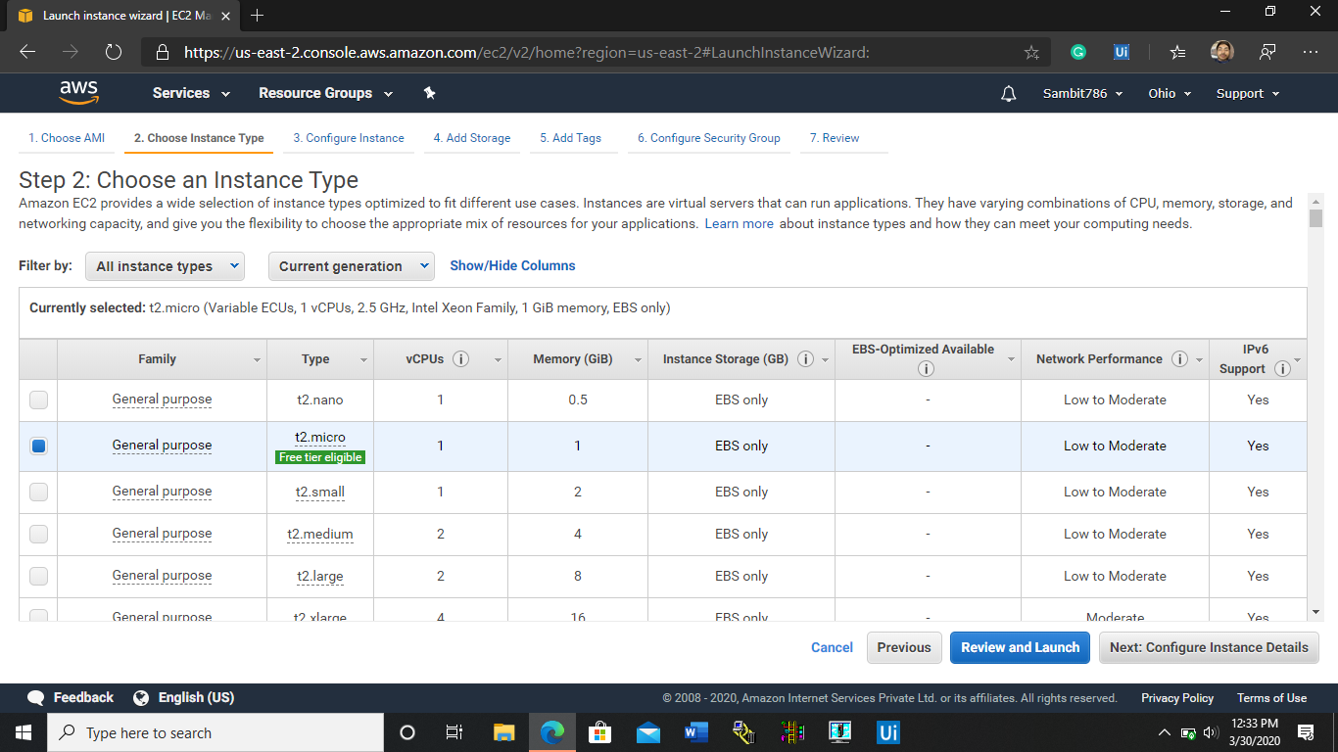
* **ADD STORAGE TO VIRTUAL MACHINE:-**

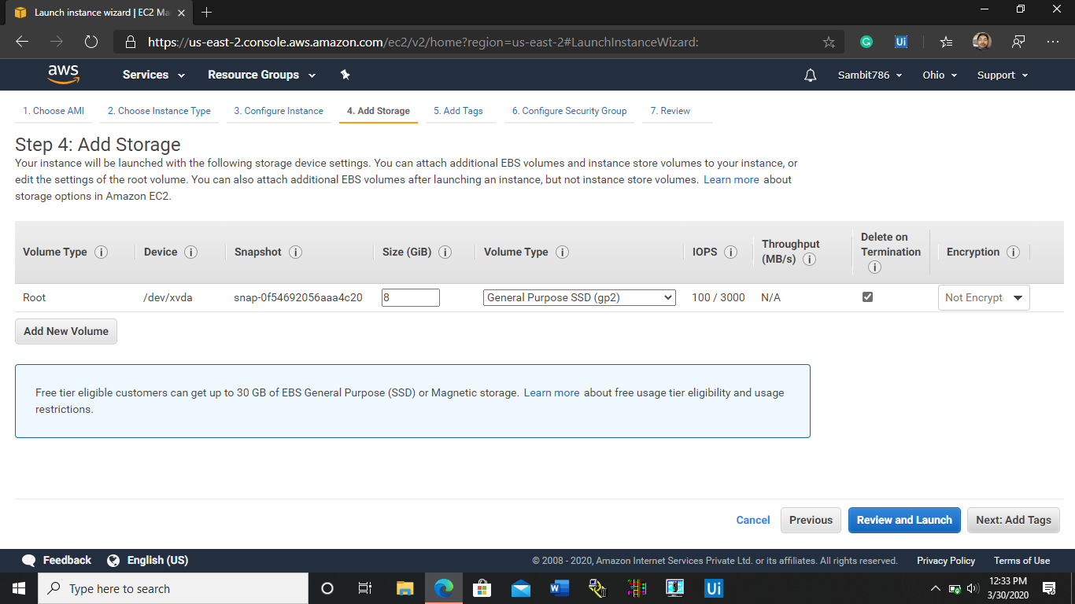

* **Configuring Security Groups:-**



* **KEY-PAIR DOWNLOAD:-**

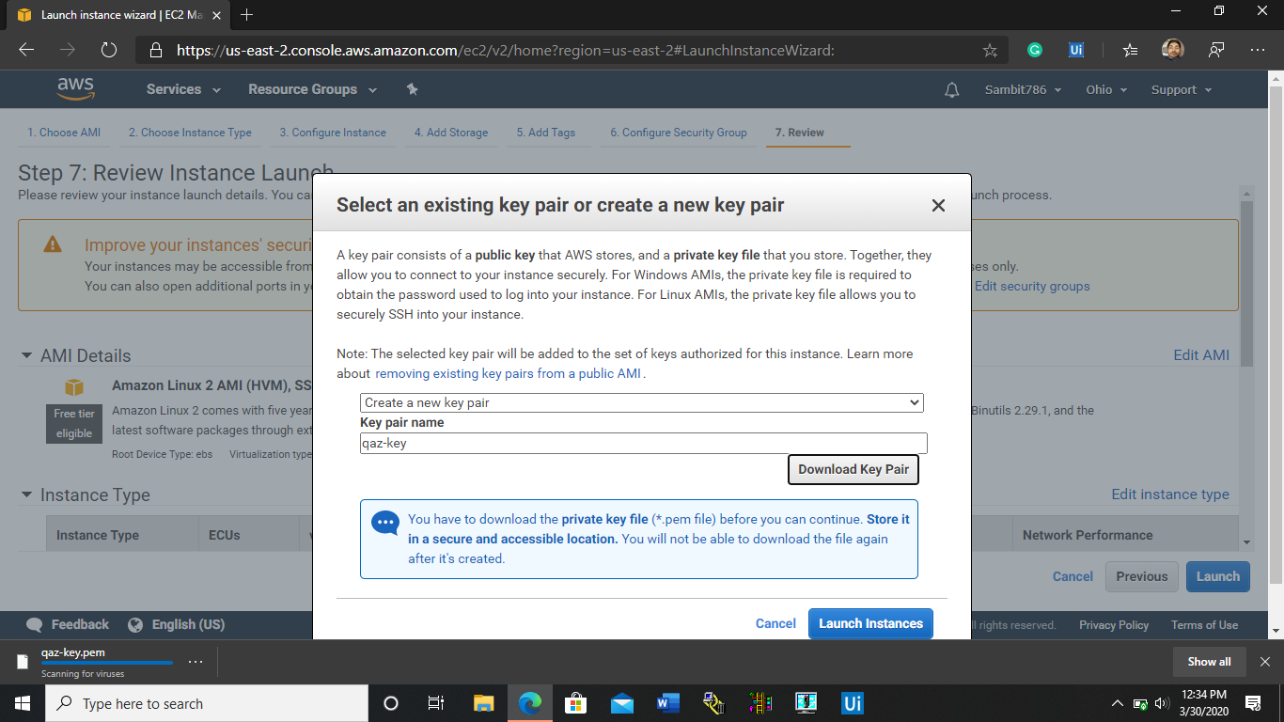

* **PUTTYGEN CONVERSION FROM .pem to .ppk:-**

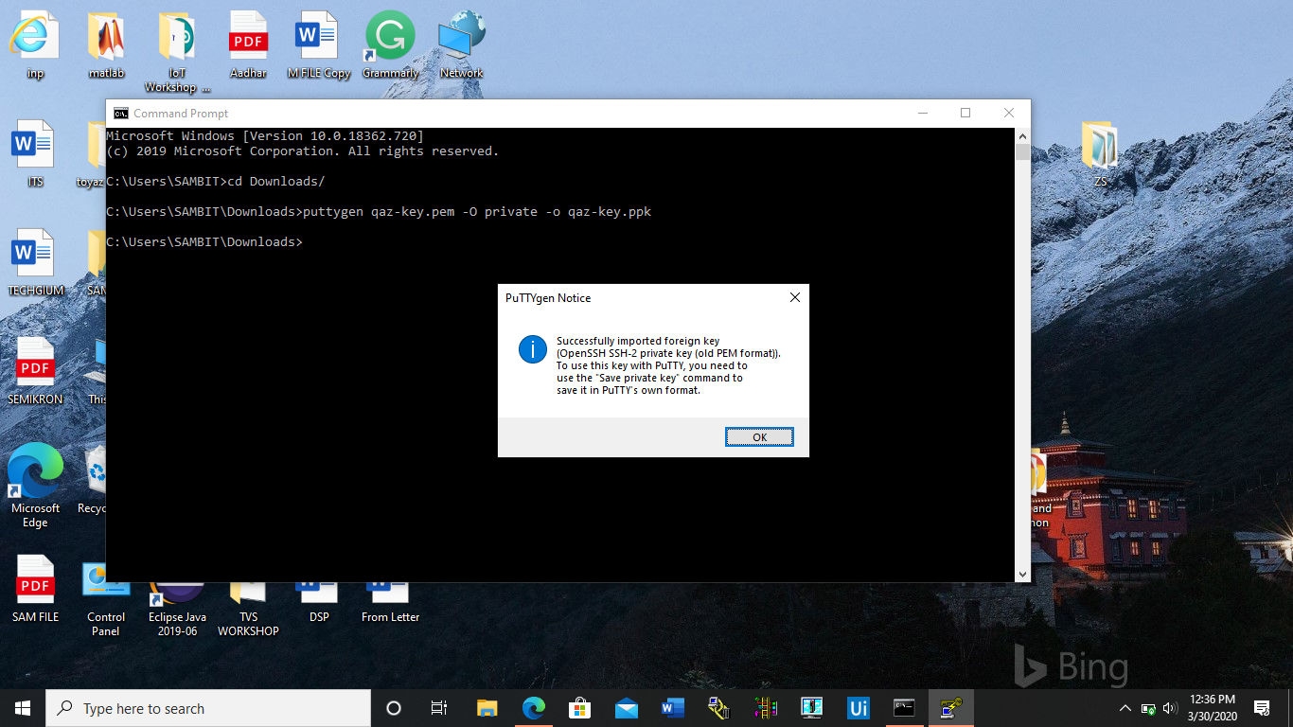

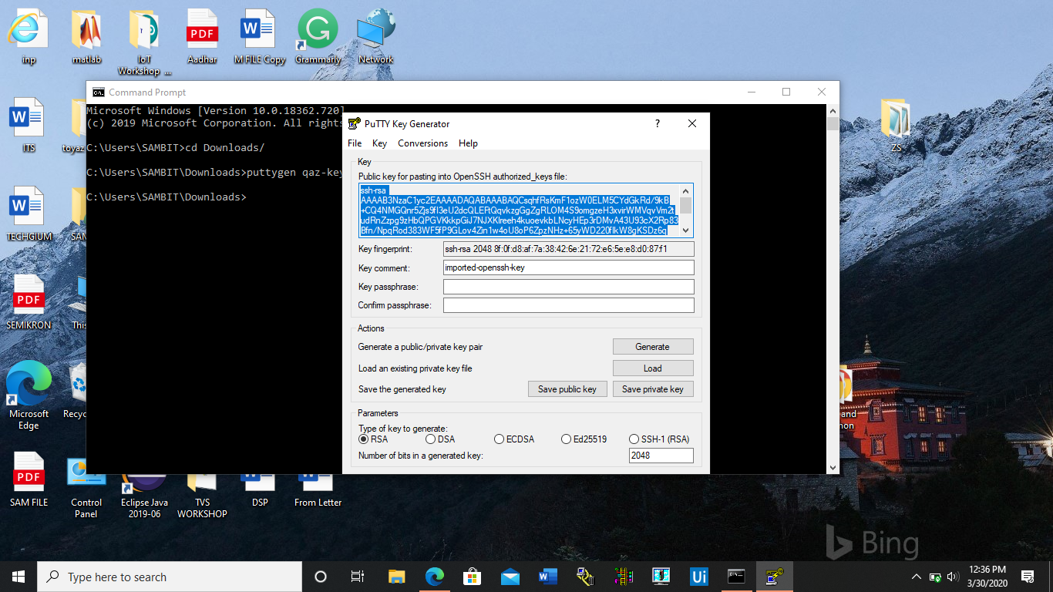

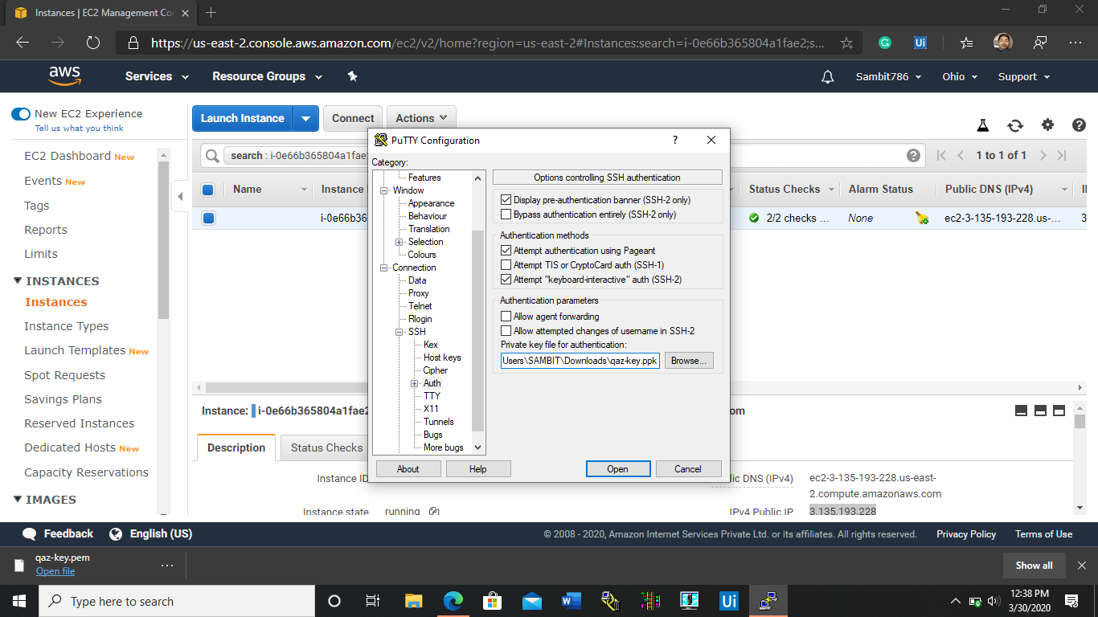

* **LOGGED IN EC2 BLACK PUTTY SOFTWARE SCREEN:-**

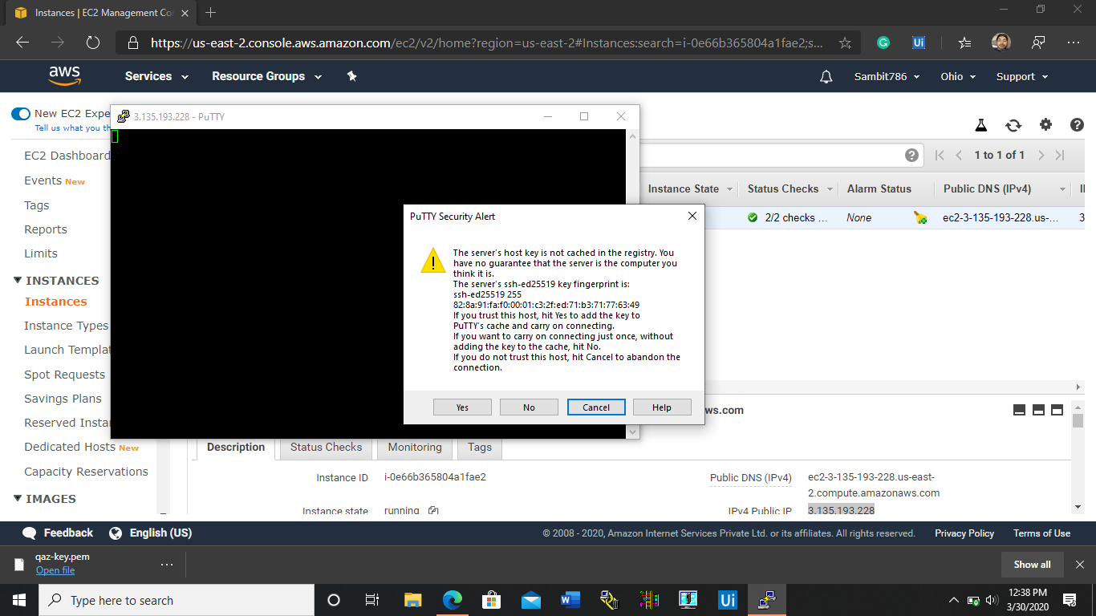

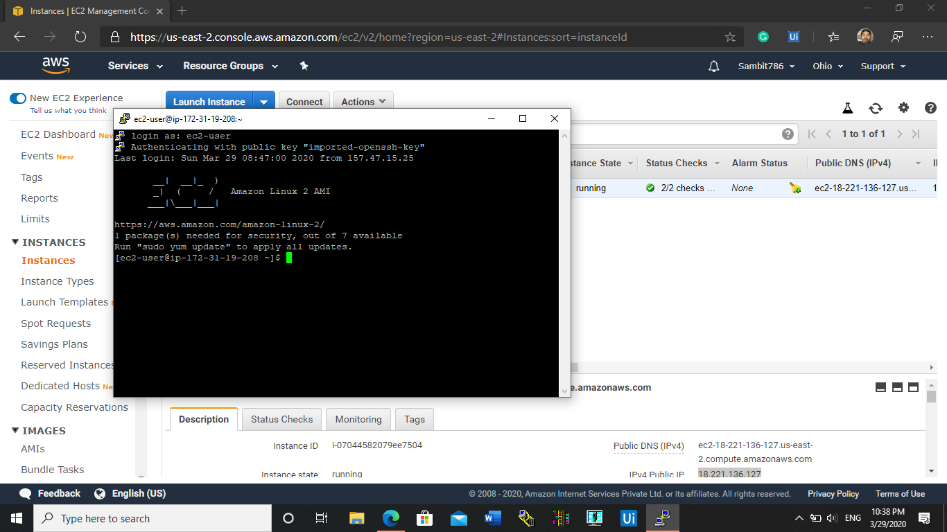

**STEPS INVOLVED IN TASKING S3 AND ITS BUCKETS:-**

* **CREATING A BUCKET:-**

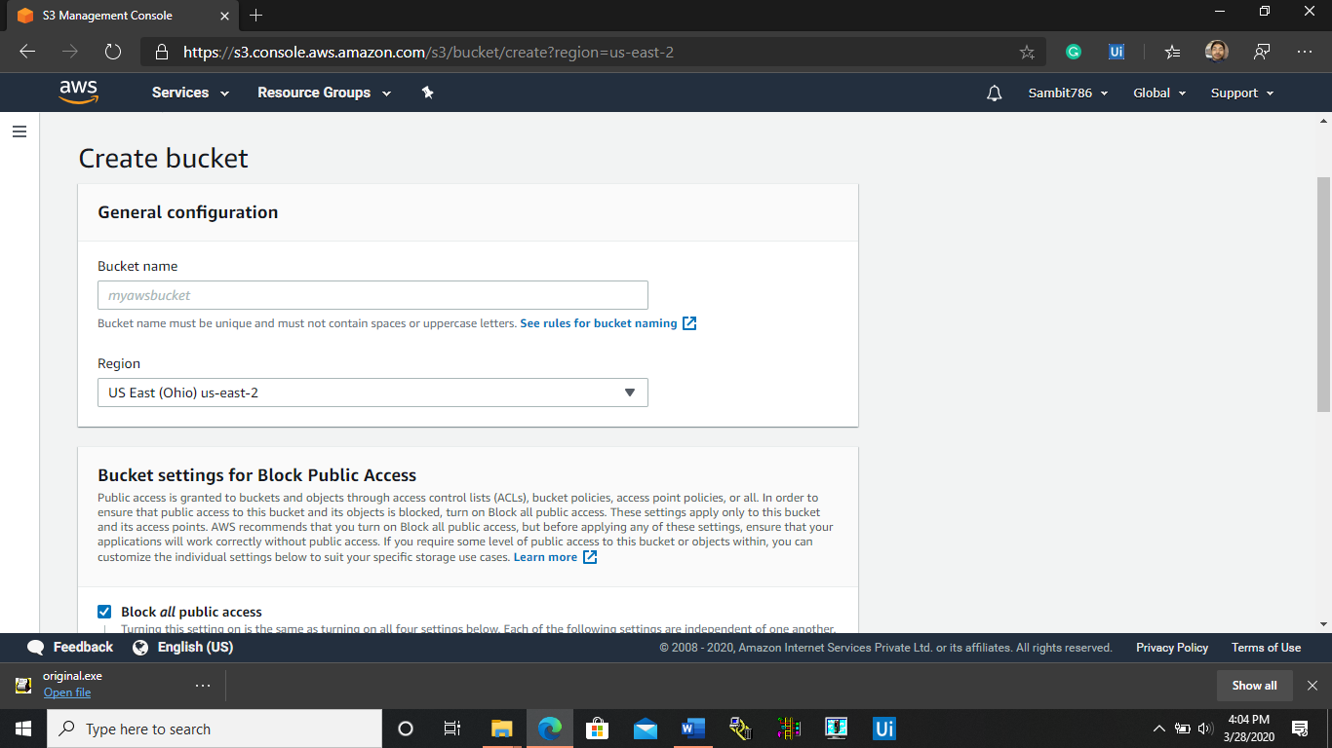

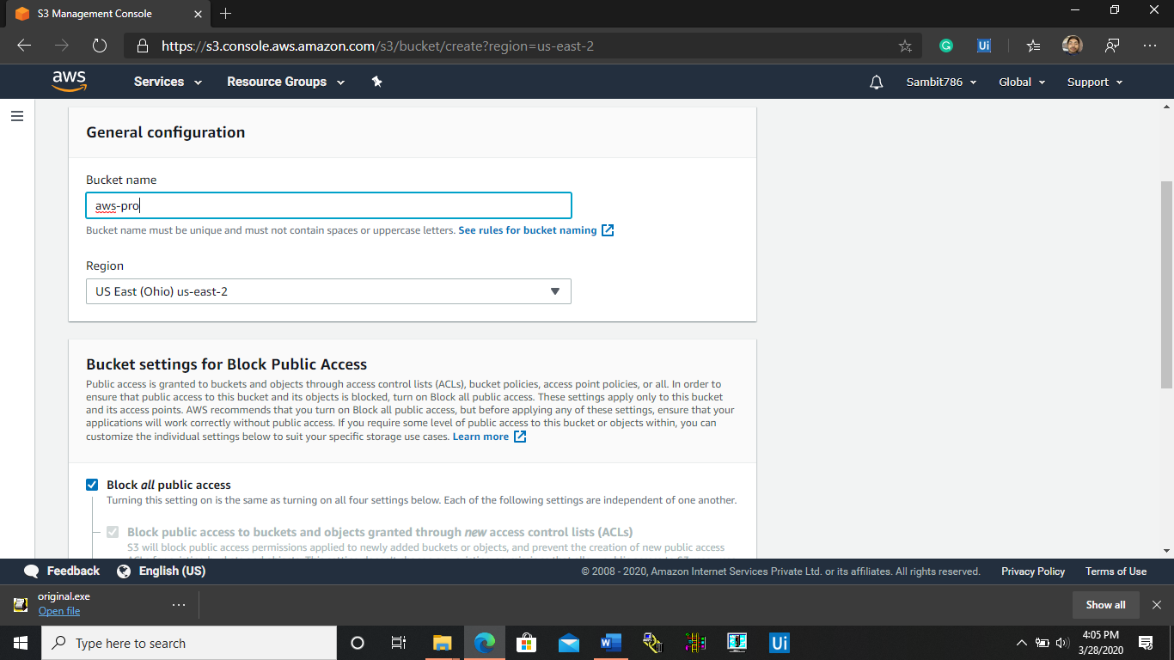

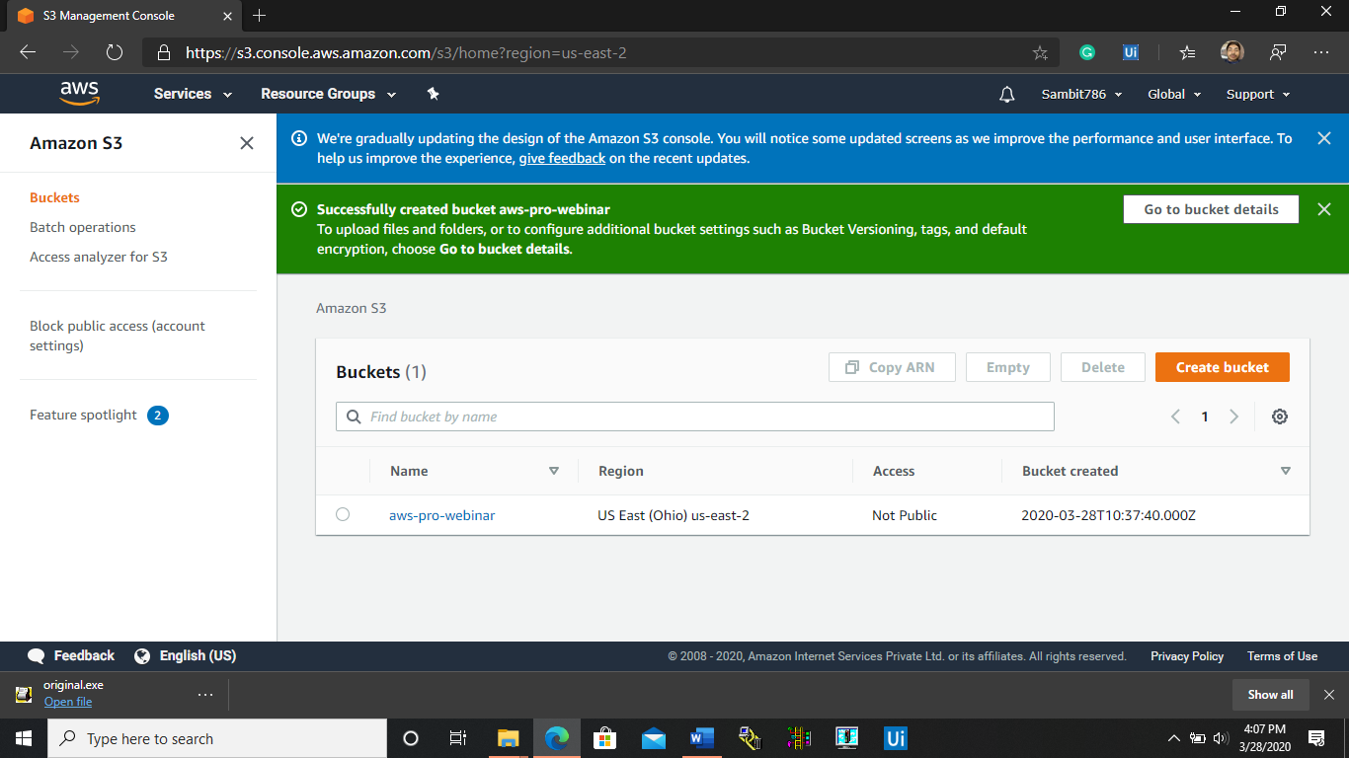

* **UPLOADING AN OBJECT INTO THE BUCKET:-**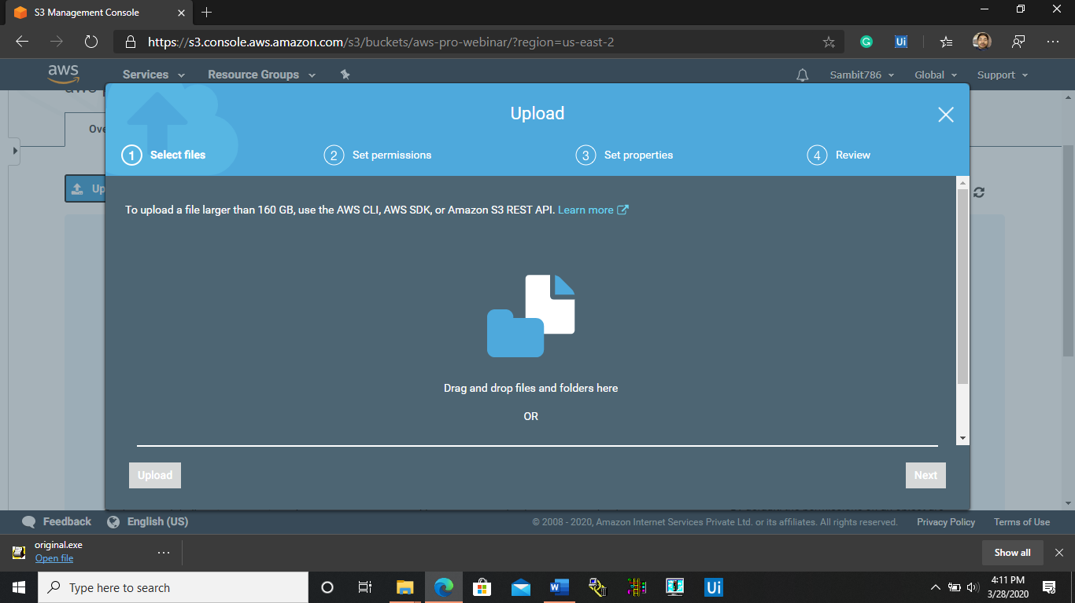

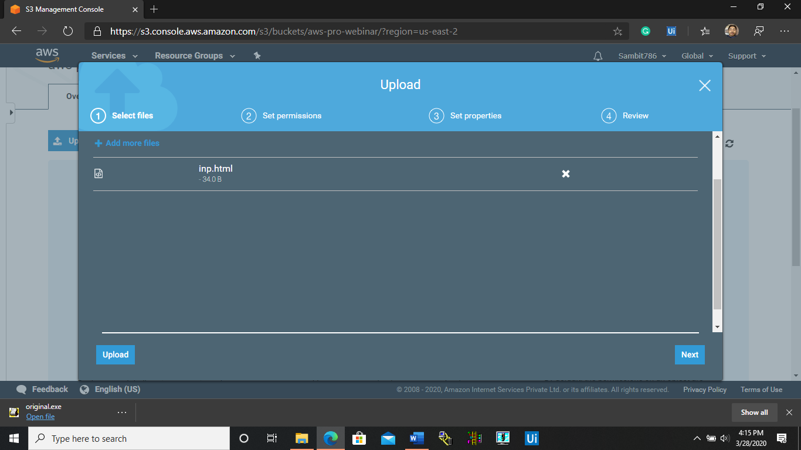

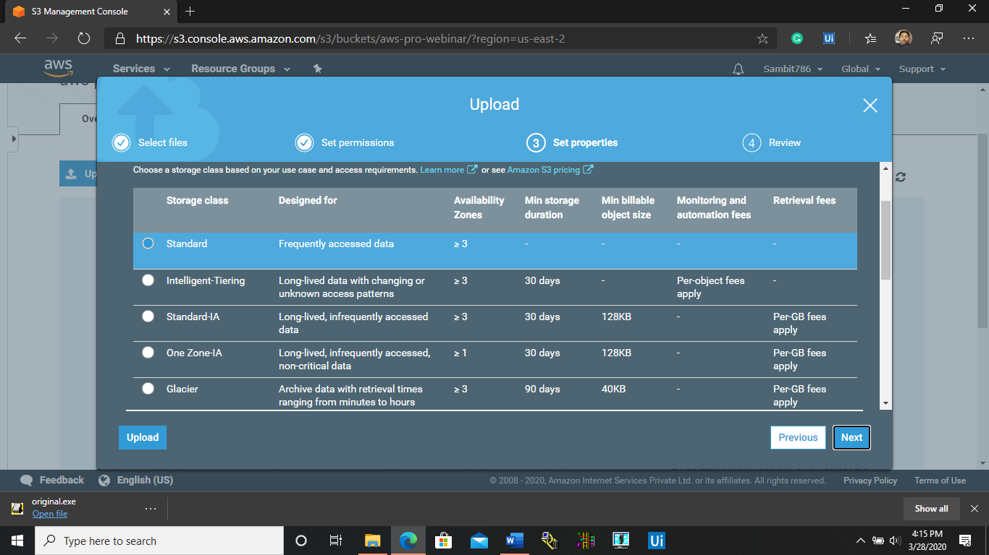

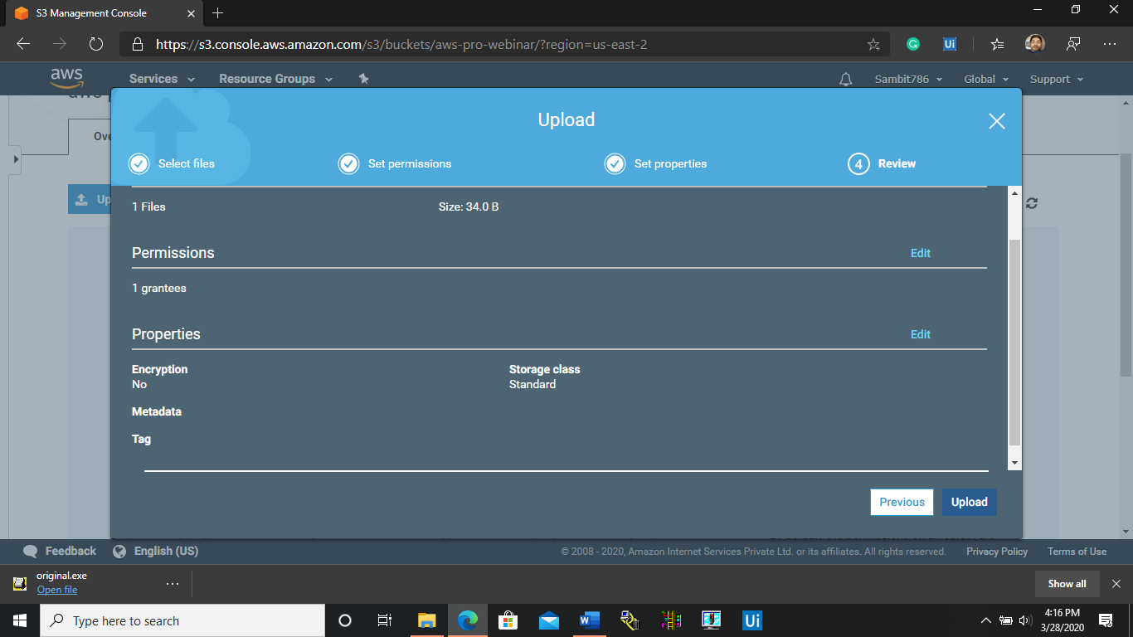

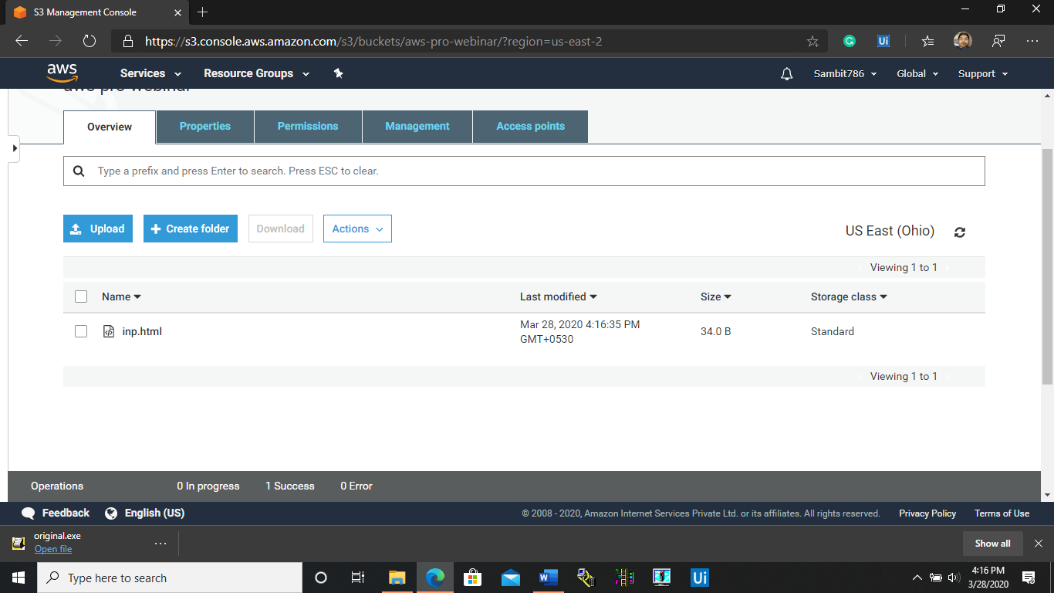

* 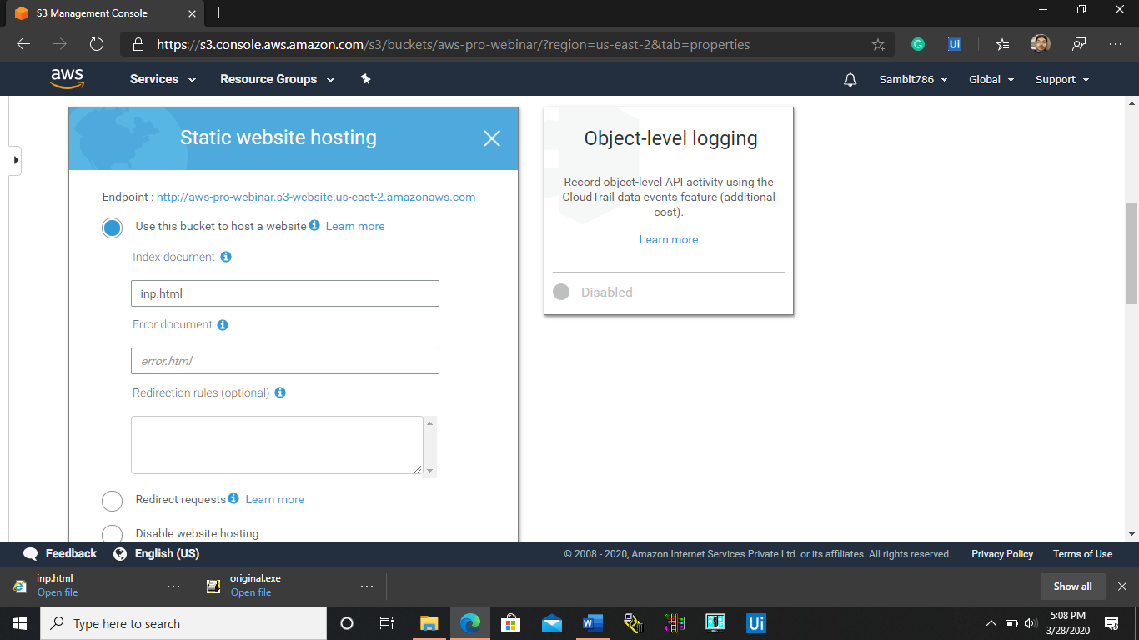**ENABLING STATIC WEBSITE:-**

* **MAKING THE OBJECT PUBLIC:-**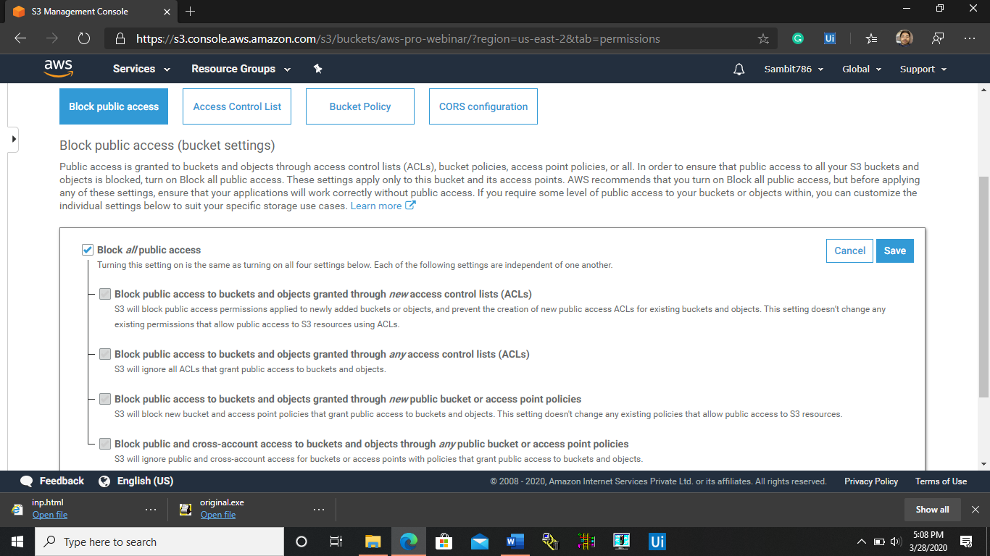

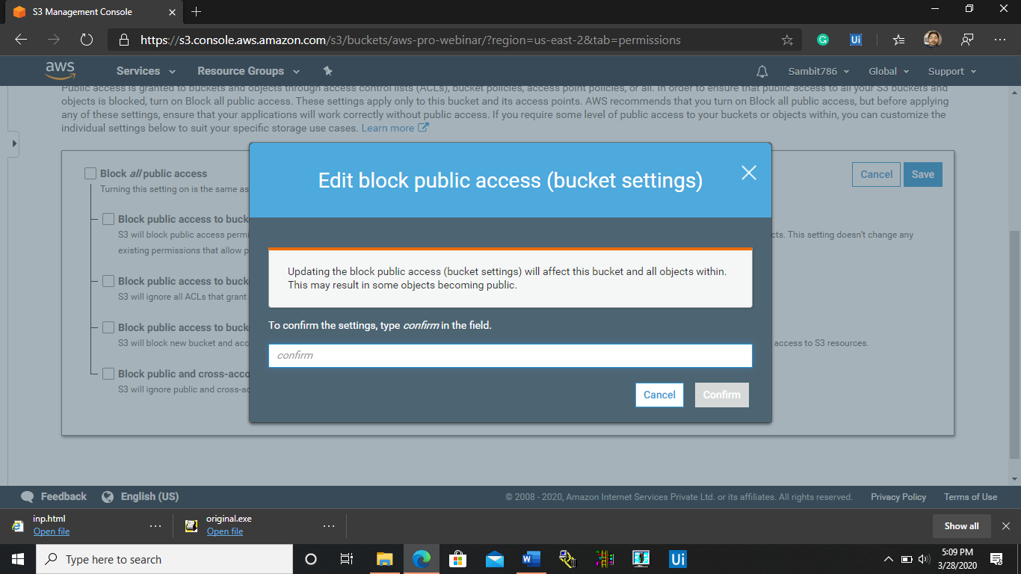

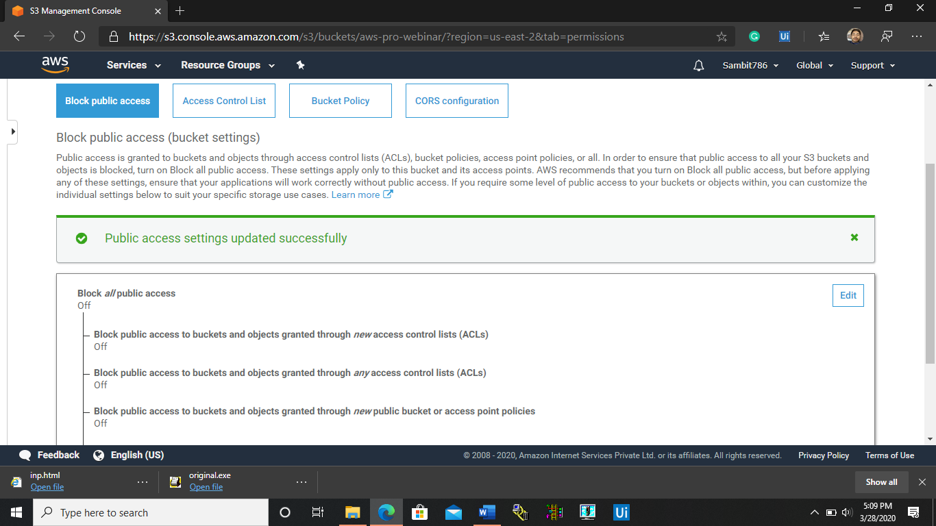

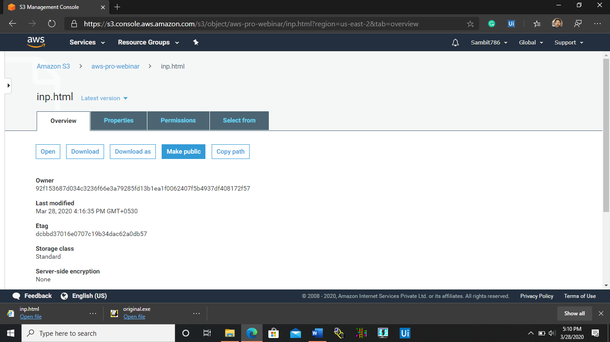

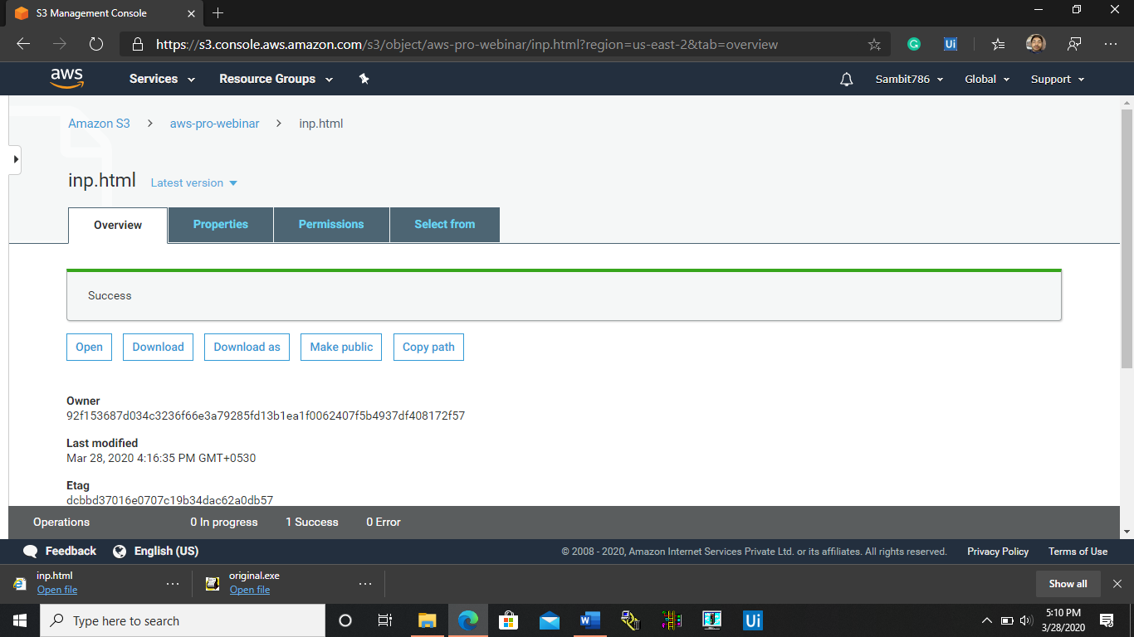

* **CREATING S3 LINK ON THE BROWSER:-**

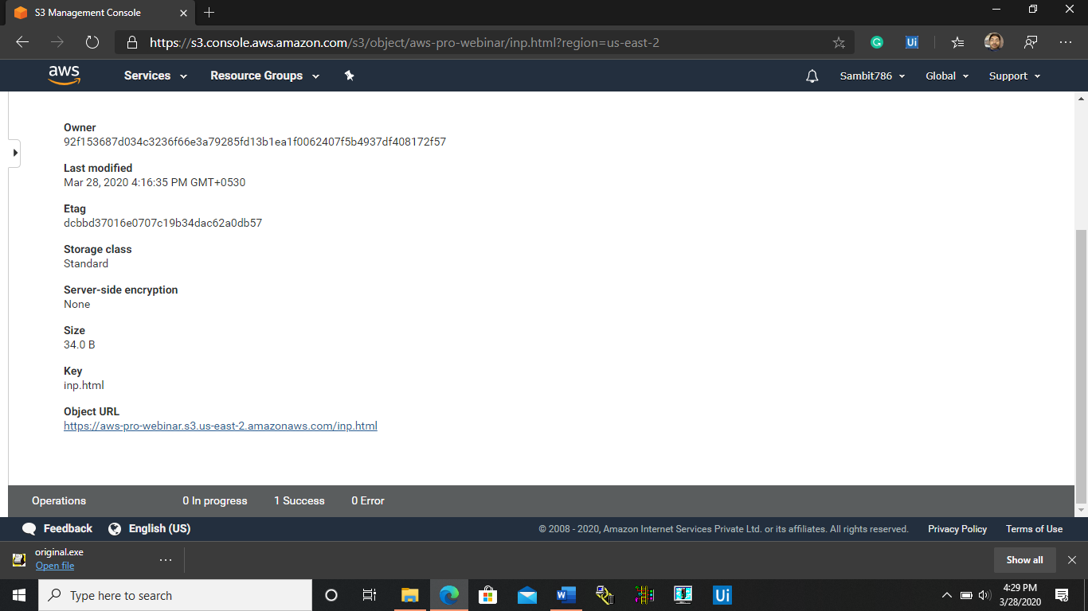

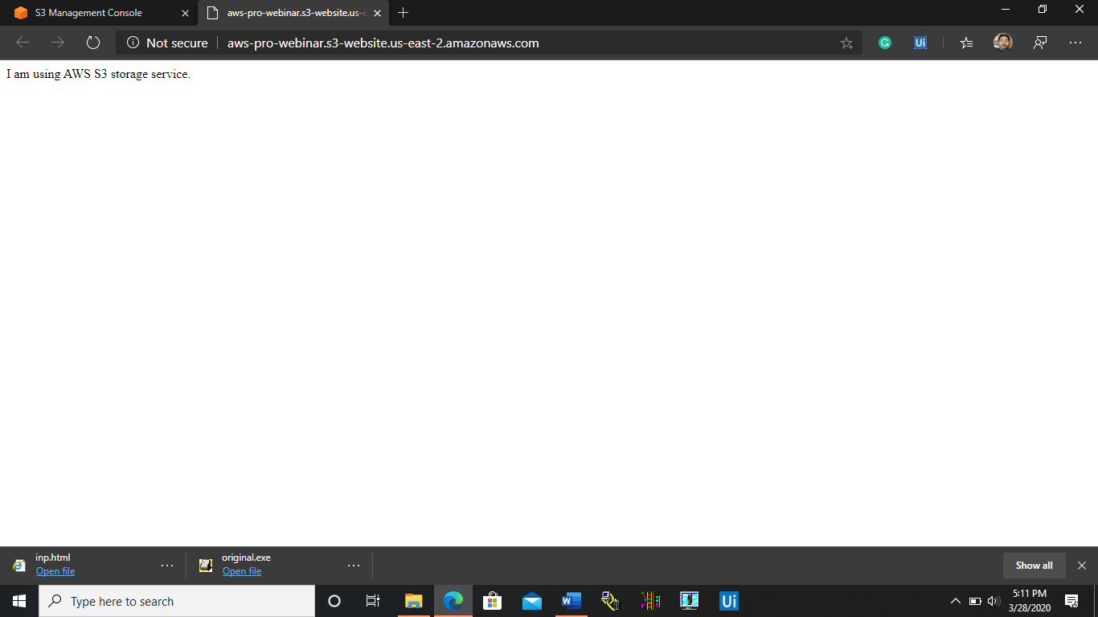

**STEPS INVOLVED IN TASKING THE AWS REKOGNITION SERVICE:-**

* **FACE DETECT:-**

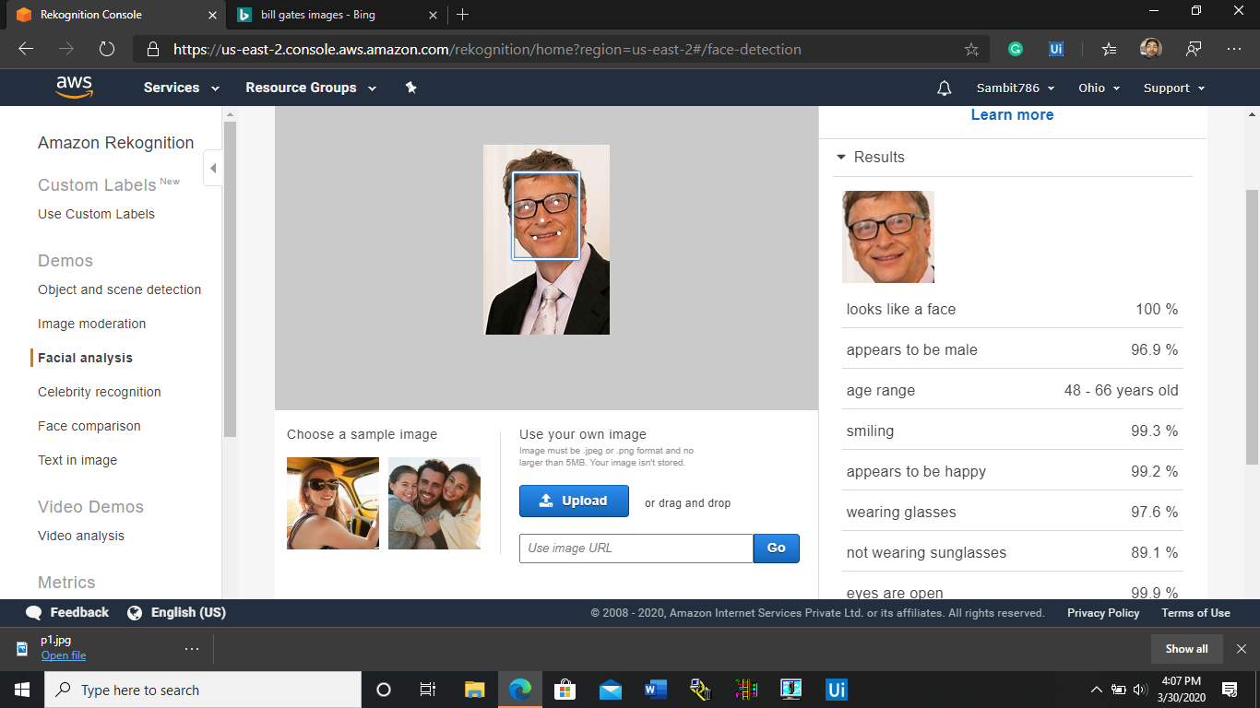

* **FACE COMPARISON:-**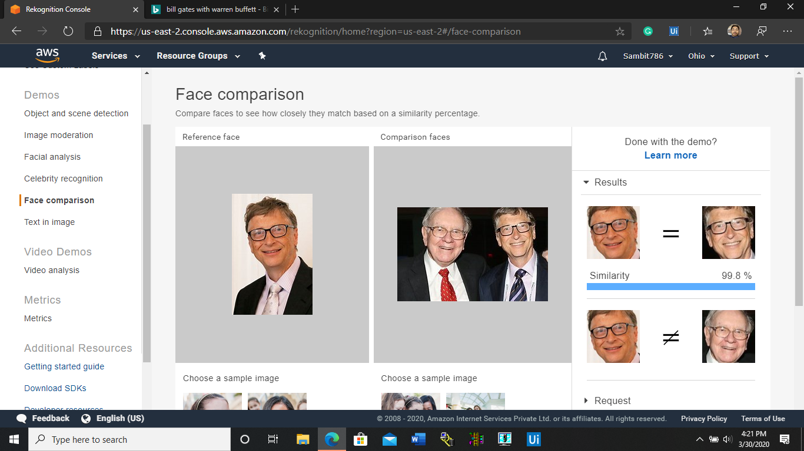
* **CELEBRITY RECOGNITION:-**

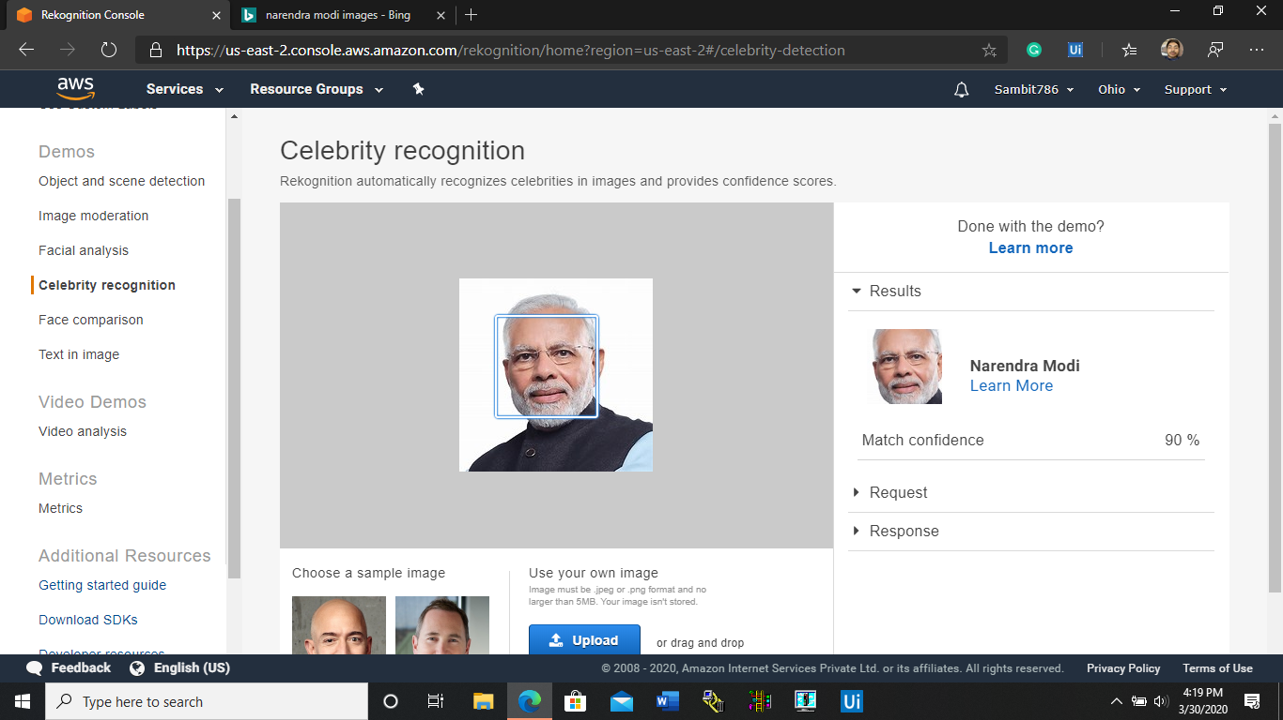

* **TEXT IN IMAGE:-**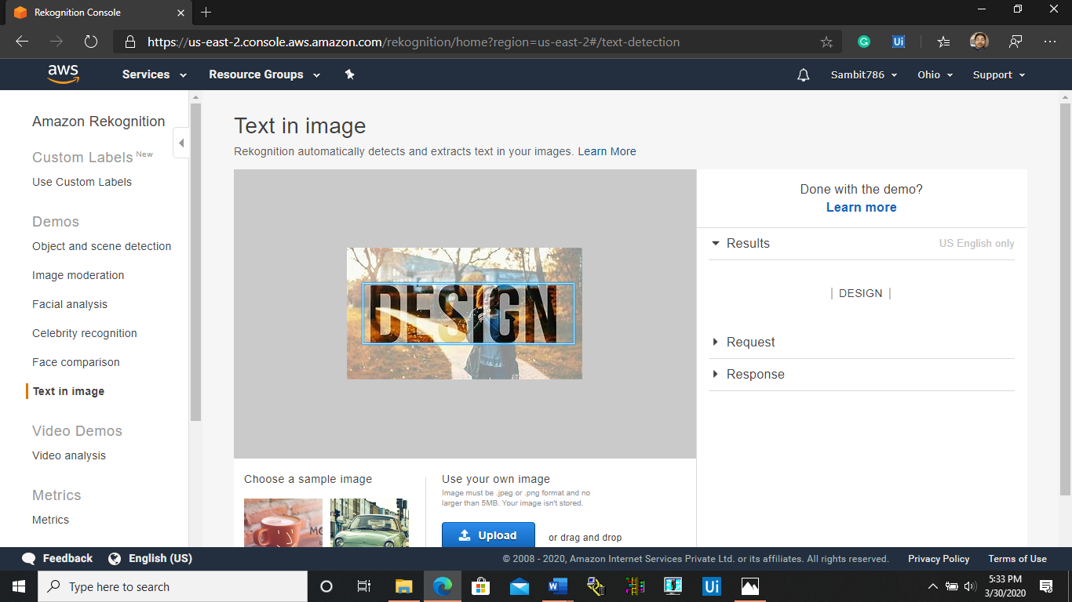

**STEPS INVOLVED IN LINKING THE EC2 AND S3 SERVICES FROM AWS:-**

* **INSTALLING AWS-SDK:-**

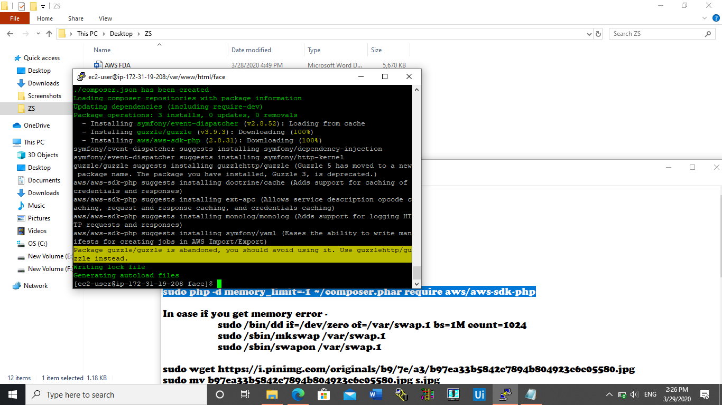

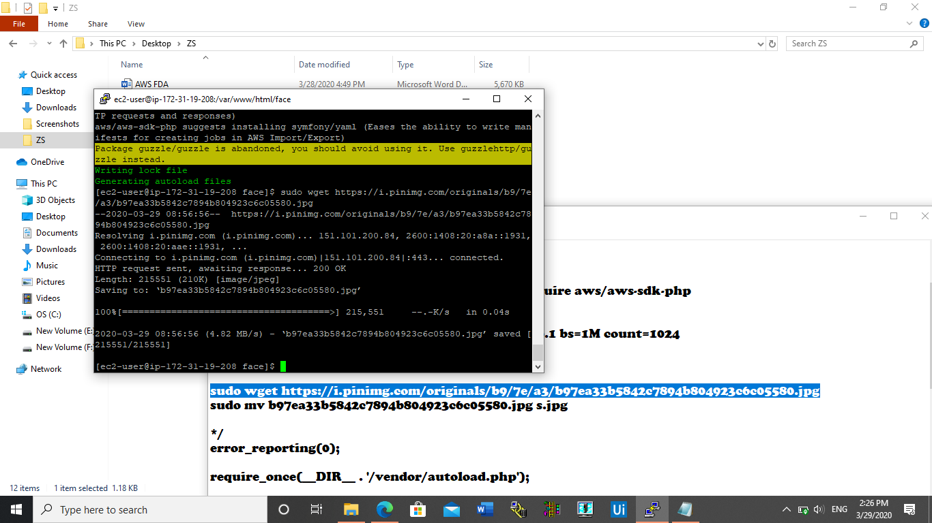

* **INSTALLING PHP:-**

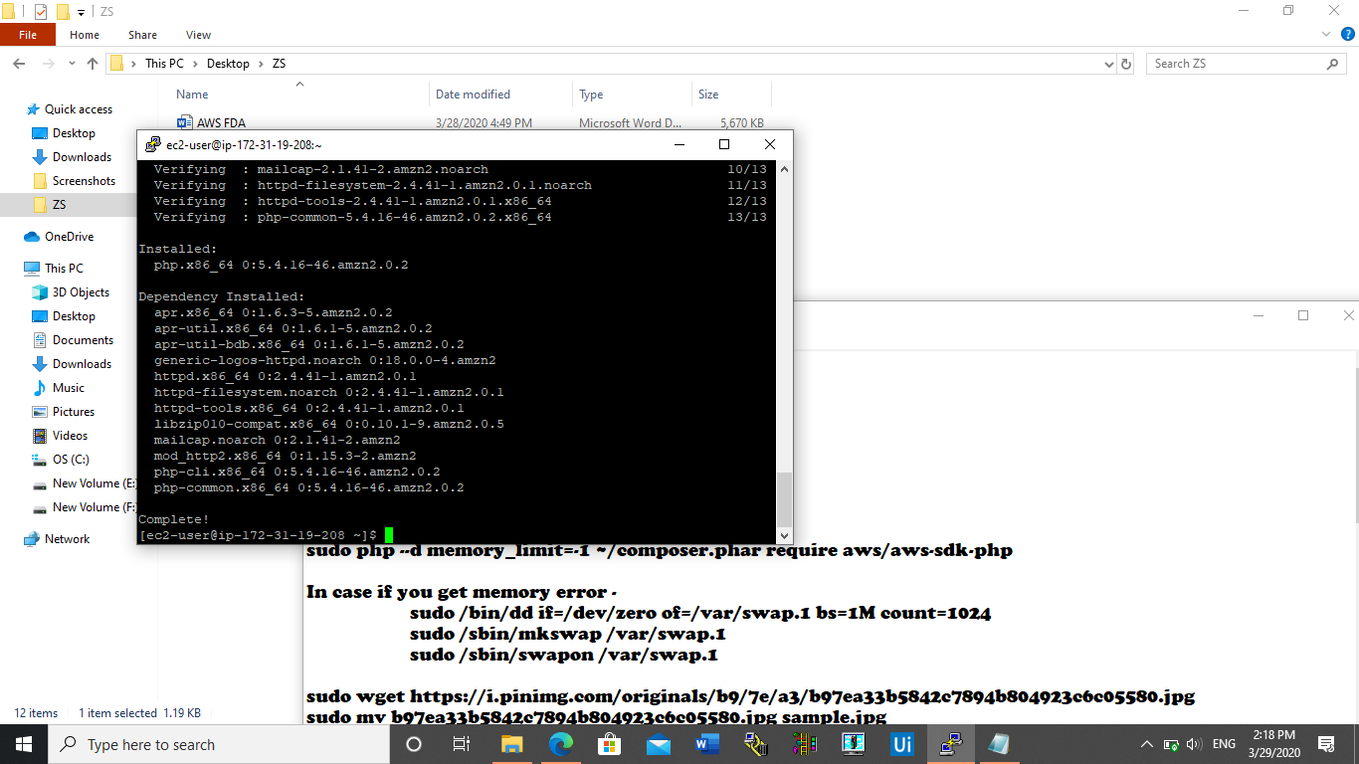

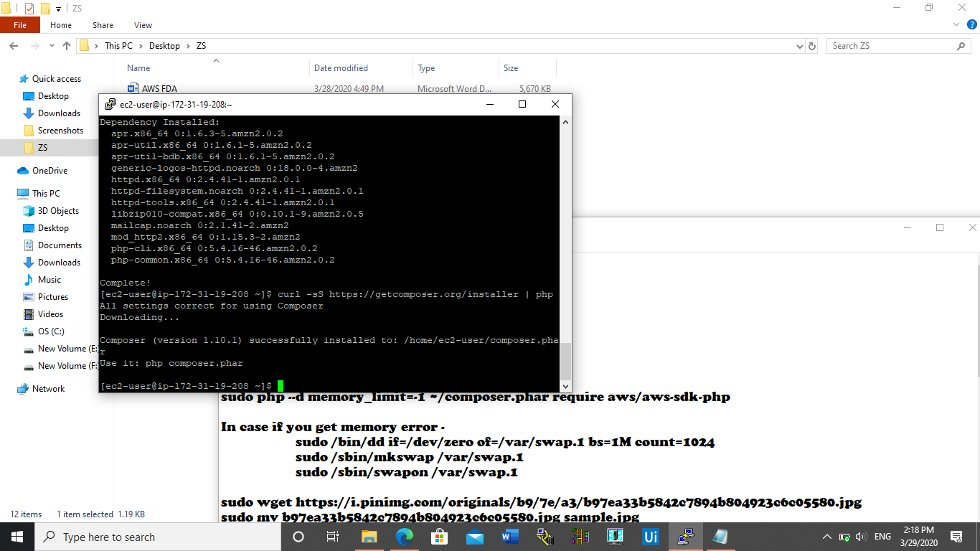

* **INDEX.PHP FILE CODE IN PUTTY:-**

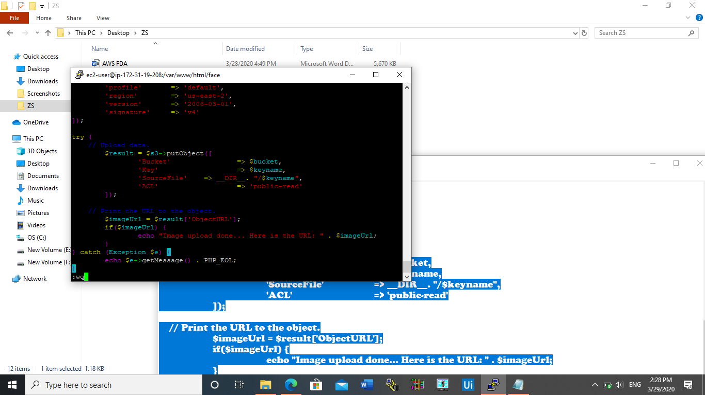

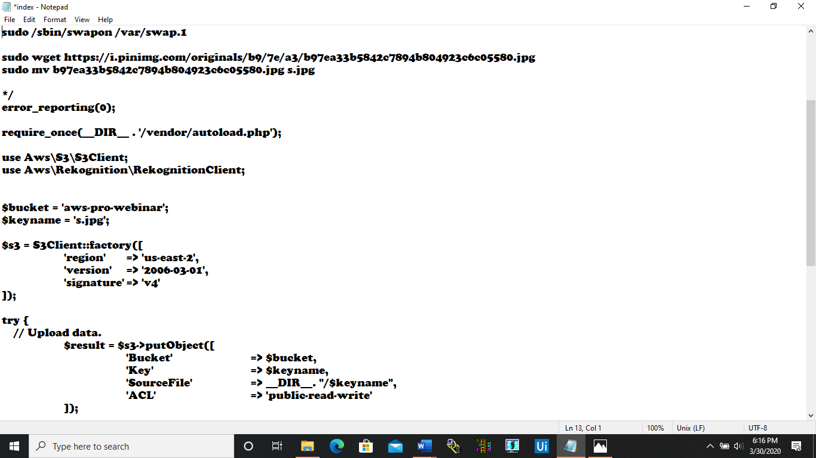

* **UPLOAD SUCCESS SCREESHOT:-**

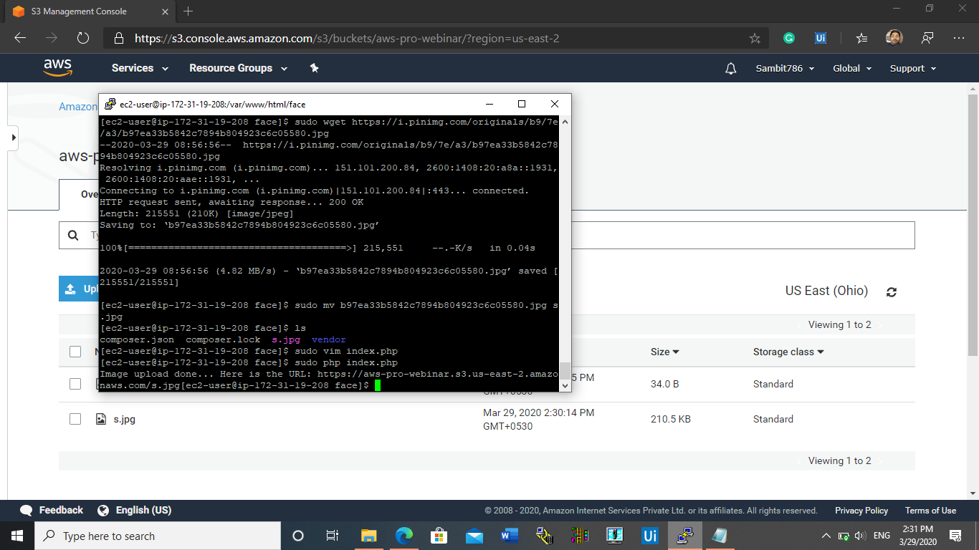

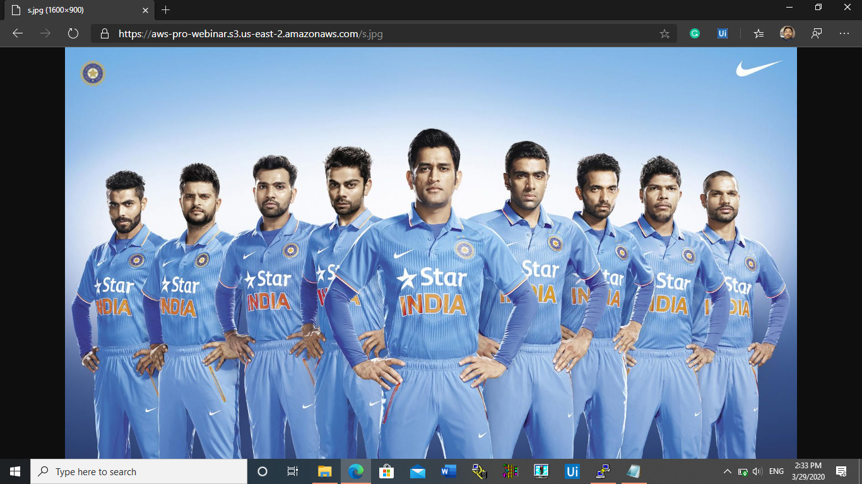

**EC2-REKOGNITION LINK:-**

* **FACE DETECT SUCCESS SCREENSHOT:-**

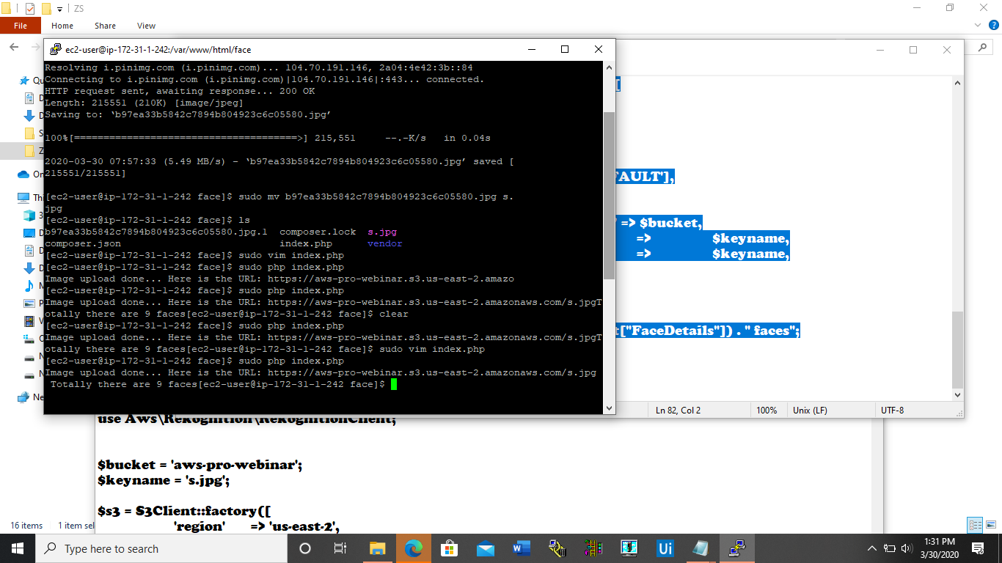

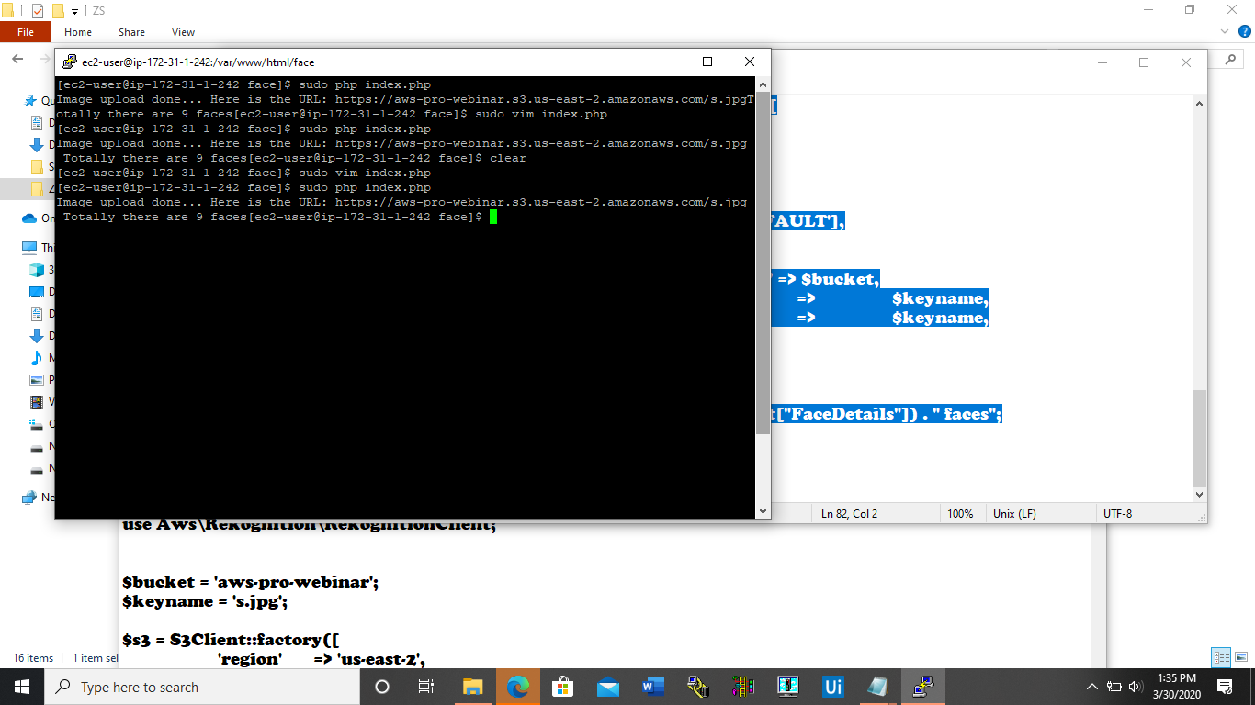

**(FOR PUTTY BASED SCREENSHOTS, THE USERNAME OF AWS IS NOT VISIBLE AS TO ZOOM TO THE BLACK SCREEN AND NOT THE UNESSENTIAL BACKGROUND SCREEN).**

**-X—END—X-**